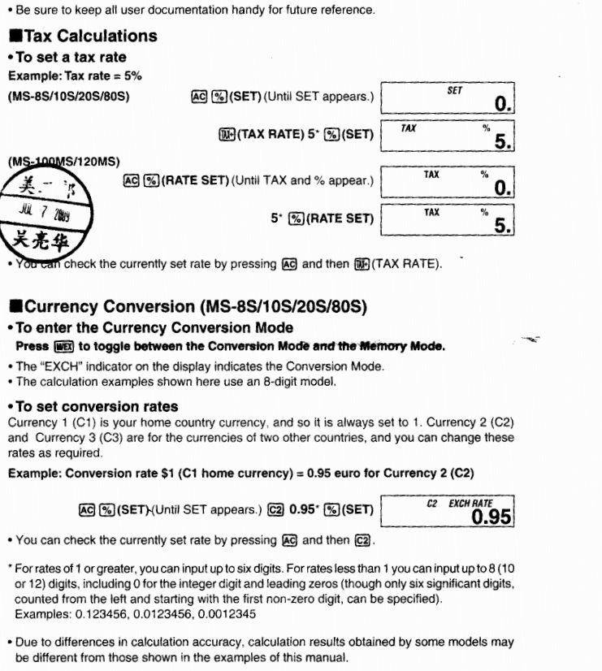

The [C] key only clears the current entry. If you need to clear the entire calculation sequence, then use the [AC] (clear all) key instead.

[+/-] is the change sign key, to change between a positive and negative value.

The [M+] key adds a value to memory, and the [M-] key subtracts a value from memory.The [MRC] key is used for both "memory recall" and "memory clear" functions. The first press of the [MRC] key recalls the value that is currently stored in memory, while the second press will clear the memory.

If you need to use one number as a factor repeatedly for several consecutive multiplication calculations, then instead of using the memory functions, it might be easier for you to use the constant function. See the following table for examples of how to use constants for various calculations (including multiplication).
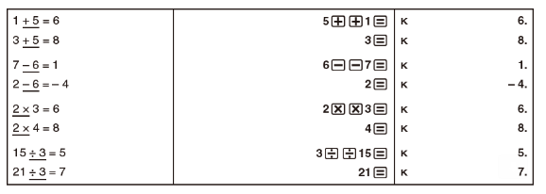

[M/EX] key
When you press the [M/EX] key, it toggles between conversion mode and memory mode. You will see "EXCH" on the display when in conversion mode.
C1, C2, and C3 are three conversion rates. C1 is your home country currency, and so it is always set to 1. C2 and C3 are rates for two other countries, which you can change.
For example, if you want to set a conversion rate of $1 to 0.95 euros, here is what you would do (using C1 for US dollars and C2 for euros):
1. Press [AC]
2. Hold [SET/%] for about two seconds until "SET" appears
3. Press [C2] to select currency 2
4. Input the conversion rate (0.95) and then press [SET/%] to store it in memory
You can check the currently set rate at any time by pressing [AC] and then [C2].
Example:
If you want to convert 100 euros to US dollars, you would do the following (assuming you are using C1 for US dollars and C2 for euros):
1. Press [AC]
2. Enter 100 and then press [C2]
3. Press [C1] to convert to dollars
4. To convert back to euros again, press [C2]
You can also perform a currency conversion within a calculation. How much in US dollars would five items selling at 100 euros cost?
1. Press [AC]
2. Enter 5 [×] 100 and then press [C2]
3. Press [C1] [=]

Programming Tax Rate
1. Press [AC]
2. Hold [SET/%] key for about 2 seconds
3. Press [TAX+]
4. Input the tax rate
5. Press [SET/%]

