WK Series Rhythms - 5/10/07
How Can I use the pre-programmed drumsets as part of the pre-programmed rhythms?

You cannot edit the rhythms on the keyboard, adding in the pre-programmed drumsets.

You can create you own User Rhythms (using those drumsets) on the computer using the Rhythm Converter component found in Casio’s Music Management software.

Example Screen: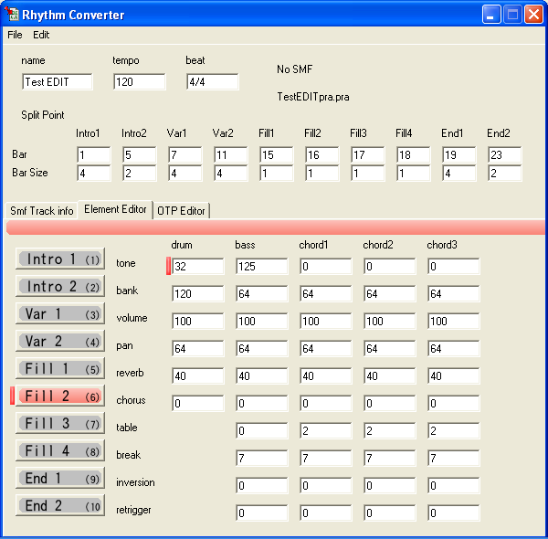

Example Screen 2
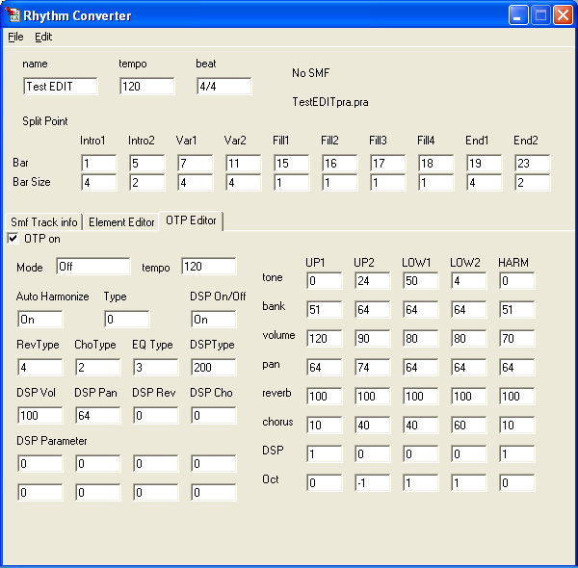

1. Open the Rhythm Converter (the 2nd box icon. top left of display). Under ‘File/ Open SMF’, select the modified midi file. Enter in the measure / length information to the boxes. For my first attempt... I didn’t worry about the ‘Element Editor or OTP (the tone instrument one touch button)

2. Select ‘File/ Convert to Pattern’.... named the file, and save it.

3. Select ‘User Rhythm’ on the computer side. Under ‘File/ Preference/ Directory’, point to the folder containing the pattern file you just made. Click on the Refresh button (the blue arrows circle). The right side (for me...with midi cables), points to the wk3000. I refreshed that side also.

4. Highlight the new pattern on the computer side, and highlight the user slot to use in the Casio, press the transfer button (arrow between the two list... the one pointing to the Casio). And the transfer was complete.

To play the new pattern... set in the ‘Fingered mode’.... press the intro button, form a “C” chord, and the song starts. I then switch between variation 1 and 2 (you don’t need to continue holding the “C”...as the variations hold the song progressions also). The ‘ending’, hold the actual bridge part... Just form the “C” chord, and switch back to the 1st variation, to continue the song. This makes a nice background for improvised melody playing (I like the 075 Feed Dist Gt)

This works whether you modify an existing file or completely create your own.

